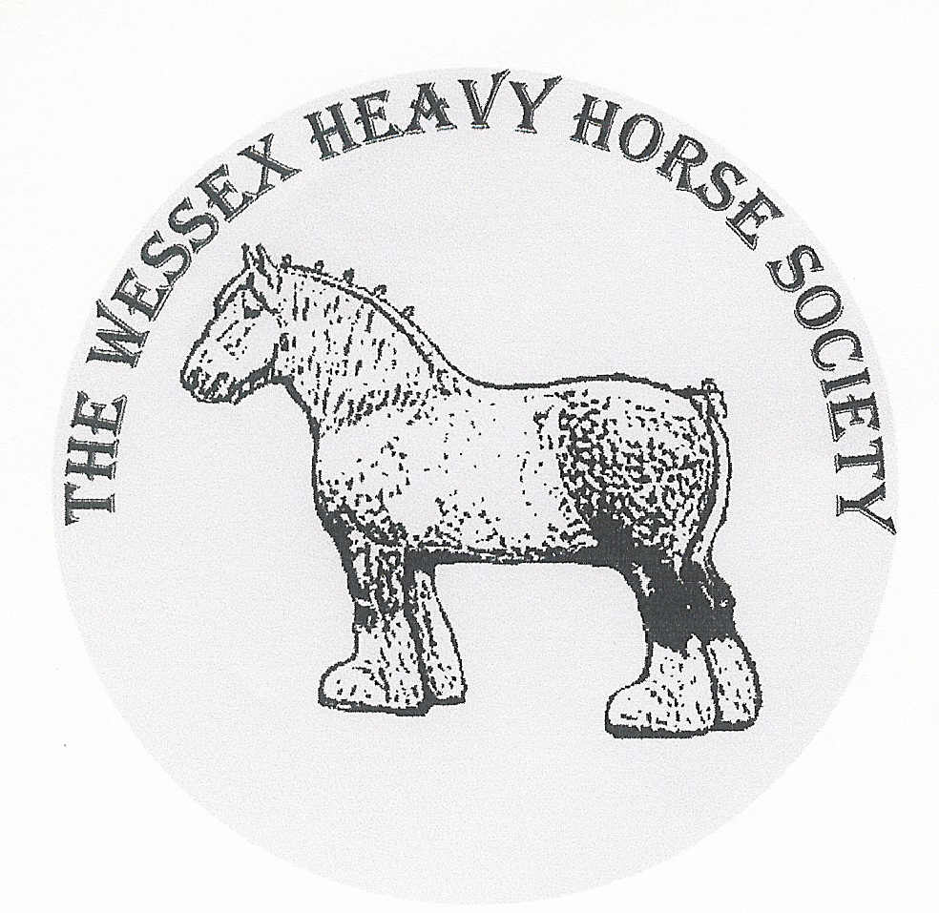

42nd WESSEX HEAVY HORSE SHOW AND COUNTRY FAIR
including
THE WEST OF ENGLAND IN-HAND AND HARNESS CHAMPIONSHIPS

AT THE TURNPIKE SHOWGROUND SP7 9PL
SUNDAY 13th SEPTEMBER 2026
TRADE / CRAFT BOOKING FORM

OUTSIDE STAND: Frontage………………………..…Metres YES/NO
£5 per foot (£50 for 3 Metres)
3M x 3M (10ft) Gazebos £100 (erected and ready for use) YES/NO
Vehicles to be parked behind the exhibit

Please note:
- We are NOT able to provide tables or electricity.
- It is your responsibility to ensure the safety of the public in your stand area
- Please enclose a copy of your current public liability insurance & risk assessment

TRADE/CRAFT NAME:…………………………………………………………………………………….

DESCRIPTION:………………………………...…………………………………………………………….

I enclose cheque/have paid by bank transfer £………… Date:………………..
Please make cheques payable to The Wessex Heavy Horse Society Limited

Your Name…………………………………………………………………………………………………..

Address……………………………………………………………………………………………………….

………………………………………………………………………………………………………………..

Telephone number……………………………………………………………………………………………

Email…………………………………………………………………………………………………………

Please return to: Mrs. Neen Macey, Oakdale, Ashington Lane, Wimborne, Dorset BH21 3DG
Emal – neenm@hotmail.co.uk - Tel: 01202 883161 mobile 07974 404829
PLEASE COMPLETE AND RETURN BY 31 AUGUST 2026

The Wessex Heavy Horse Society Ltd
NatWest Bank plc
Sort Code: 60-24-43 Account number: 14195275 REF: TR plus trade name

